VCEv3 for Developers

Bartlomiej Szejna, INRIA Oasis team 18.11.2013
bartlomiej.szejna@inria.fr

- Introduction

This document helps developers for VCEv3 in understanding a project architecture and provide simple steps to configure their local workspace.

- Configuring Obeo designer

  - Download Obeo designer from http://www.obeodesigner.com/download
  - In Obeo install via Eclipse Marketplace fallowing plugins (this step is not necessary but strongly recommended) :
    - Subversive -SVN team provider (http://www.eclipse.org/subversive/installation-instructions.php)
    - Maven Intergation for Eclipse

- Working with SCM

  - Checkout
All VCEv3 source files are stored at INRIA GForge. At https://gforge.inria.fr/scm/?group_id=193 developer can find all information required to successfully checkout project (via eclipse subversive for example) on their local workspace. Recommended is to use url: https://scm.gforge.inria.fr/svn/vercors as a repository location information. Most recent version is accessible at trunk/software/VCEv3/. Please remark that only registered users in GForge and invited to Vercors project can commit changes.

  - Project versioning standard
VCEv3 fallows x.y.z versioning standard, where:
  - x – always is number '3'
  - y – increment only for major change
  - z – bug fix
Please remark when commit does not involve business logic (add/remove javadoc, checkstyle) version number suppose not to be incremented.

  - Before commit changes
Before commit any changes please comment a commit properly and for increasing version number please use script scripts/updateVersion. Do not commit target and bin folders since they contain local build

- Brief explanation of VCEv3 modules

VCEv3 contains of 12 modules and 1 parent project:
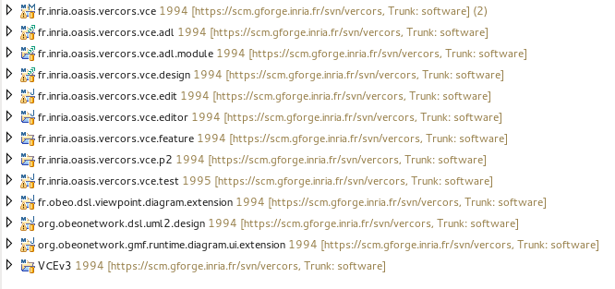

- fr.inria.oasis.vercors.vce – plugin module, consist of VCEv3 meta-model
- fr.inria.oasis.vercors.vce.adl – plugin module, export model to ADL file
- fr.inria.oasis.vercors.vce.adl.module – Acceleo module to gonerate Java interfaces
- fr.inria.oasis.vercors.vce.design – plugin module, for graphical editor
- fr.inria.oasis.vercors.vce.edit – plugin module, standard EMF edit generated from meta-model
- fr.inria.oasis.vercors.vce.editor – plugin module, standard EMF editor generates from meta-model
- fr.inria.oasis.vercors.vce.feature – feature module, aggregates VCEv3 to one feature
- fr.inria.oasis.vercors.vce.p2 – p2 repository module, generates p2 repository for VCEv3
- fr.obeo.dsl.viewpoint.diagram.extension – plugin module, helps to change a picture of an interface
- org.obeonetwork.dsl.uml2.design – plugin module, implements a graphical editor of UML diagrams
- org.obeonetwork.gmf.runtime.diagram.ui.extension – plugin module, is used by UML designer (by org.obeonetwork.dsl.uml2.design plugin) for the rotation of required and provided interfaces on the UML Composite Structure Diagrams.
- fr.inria.oasis.vercors.vce.test. – test module, see paragraph 6.3

- Running VCEv3 in Obeo

In order to run VCEv3 in Obeo, developer must to make sure that all plugins modules projects are imported, in other words they are visible in Package Explorer. Run fr.inira.oasis.vercors.vce as Eclipse application.

- VCEv3 build

  - Maven
Whole VCEv3 project is mavenized, in parent pom (VCEv3 project) all dependencies, repositories, additional plugins, modules are set.
There exist 2 ways of building project:
  - run in console mvn install in root of project
  - in Obeo Designer, click right click on project VCEv3->Run As->Maven install

  - Tycho
Building Eclipse plugin is provided by Maven plugin, Tycho. For each pom.xml in all modules one of the fallowing packaging is set:
  - “eclipse-plugin” builds module as Eclipse plugin
  - “eclipse-feature” groups all plugin modules as one feature
  - “eclipse-repository” creates p2 repository for VCEv3 with specified category

  - VSM test module
Test module fr.inria.oasis.vercors.vce.test runs independently Obeo designer and checks validity of provided models. Module in folder Models models to check and configuration.json file. Configuration file uses Json syntax. In order to add a new model to test, copy model file (*.vce) to Models and update configuration file by adding a new line:

{name:"model_name.vce",valid:true}

where:
  - name – model name
  - valid – true if model is valid, false otherwise

In order to skip test while building an project, add skipTests flag: mvn install -DskipTests

When test fails please share target/surefire-raports on bug tracker or contact any of developers

- Add a new project (plugin module) to VCEv3
General steps:
  - Create plugin project (fallow vce naming convetion)
  - Convert it to Maven project
  - Set parent pom (fr.inria.oasis.vercors) with latest version in pom.xml
  - Set eclipse-plugin as packaging in pom.xml
  - In Manifest file set same version as it is in parent pom with .qualifier, example:
  - pom.xml – 3.0.10-SNAPSHOT
  - Manifest.mf – 3.0.10.qualifier

  - In parent pom add newly created project as a new module element
  - Add newly created plugin to feature.xml file in fr.inria.oasis.vercors.vce.feature project with 0.0.0 version

- Continuous integration with Jenkins
Jenkins continuous integration server http://jenkins-ci.org/ has been set to ease development and generate VCEv3 p2 repository. Selective information of Jenkins for VCEv3:
  - Accessible at host antofagasta at port 8080
  - Daily builds with tests
  - Weekly updates p2 repository /net/servers/www-sop/teams/oasis/Vercors/software/VCE-v3 available from outside at http://www-sop.inria.fr/oasis/Vercors/software/VCE-v3/repository/

- Bug tracker
In Vercors project we use simplistic bug tracker available at https://gforge.inria.fr/tracker/?group_id=193

